**COST FUNCTION**

Before we learn about CF lets clear some terms required to understand CF.

**Input/output variables:**

X denotes matrix of input variables, whereas Y denotes matrix of output variables.

**Hypothesis:**

To describe the supervised learning problem slightly more formally, our goal is, given a training set, to learn a function h : X → Y so that h(x) is a “good” predictor for the corresponding value of y. For historical reasons, this function h is called a hypothesis.

**Model representation:**

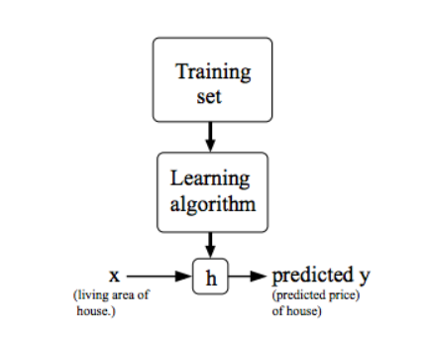

**COST FUNCTION :**

We can measure the accuracy of our hypothesis function by using a cost function $J(θ{}_{0},θ{}_{1})$.

This function is otherwise called the "Squared error function", or "Mean squared error".

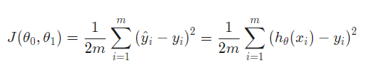

To break it apart, it is $\frac{1}{2} xˉ$ where $xˉ$ is the mean of the squares of $h{}_{θ}(x{}_{i})-y{}_{i}$ or the difference between the predicted value and the actual value.